**TEMPLATE EXAMPLE: Using screenshots along with red highlight boxes to show changes to existing pages and content. Please make a copy of this, and revise all the boilerplate to be relevant to your project and stakeholders.**



**Burials and memorials benefits content updates for VA.gov**

**Copy Deck 2 of 4**

**Summary:** As part of the November 2018 launch of the new VA.gov, we audited all Veteran-facing benefits content in an effort to create a single source of truth for each benefit and service. Vets.gov benefits content was migrated to VA.gov, and now we’re updating content to reach parity with the VA.gov benefits content that existed before migration.

**Reviewer instructions:**

* Review the content additions in the red boxes. This is the new content that we’d like to add to pages that already exist on VA.gov. The rest of the content that’s not in red boxes was previously approved by stakeholders. - The source content URLs are listed above these content additions.
* Is the new copy accurate? If not, please keep track of what needs changing. We can take your written feedback or would be happy to meet to discuss any needed changes.

The web content team has carefully written and edited this content to align with the voice, tone, and plain language standards outlined in the [VA.gov content style guide.](https://design.va.gov/content-style-guide/content-principles) (For example: the new VA.gov content principles call for avoiding formal language and employing empathetic language.) Out of respect for SMEs time and to keep things moving forward, please focus on flagging any inaccuracies for us. We’re not looking for you to edit line by line, as we’ll have a professional copy editor review the content after you’ve verified the accuracy of the information.

Here are the 9 pages to review that are covered in the 4 copy decks. You can read the updated pages in their entirety by clicking each of these links. And/or, to see the specifics of what has changed on each of these pages, keep scrolling through this copy deck. Our proposed additional content is boxed in red in screen shots in this doc.

<https://vagov-content-pr-137.herokuapp.com/burials-memorials/eligibility/>[https://vagov-content-pr-137.herokuapp.com/burials-memorials/pre-needeligibility/](https://vagov-content-pr-137.herokuapp.com/burials-memorials/pre-need-eligibility/)

[https://vagov-content-pr-137.herokuapp.com/burials-memorials/pre-needeligibility/after-you-apply/](https://vagov-content-pr-137.herokuapp.com/burials-memorials/pre-need-eligibility/after-you-apply/)

[https://vagov-content-pr-137.herokuapp.com/burials-memorials/veterans-burialallowance/](https://vagov-content-pr-137.herokuapp.com/burials-memorials/veterans-burial-allowance/)

[https://vagov-content-pr-137.herokuapp.com/burials-memorials/memorialitems/headstones-markers-medallions/](https://vagov-content-pr-137.herokuapp.com/burials-memorials/memorial-items/headstones-markers-medallions/)

[https://vagov-content-pr-137.herokuapp.com/burials-memorials/memorialitems/burial-flags/](https://vagov-content-pr-137.herokuapp.com/burials-memorials/memorial-items/burial-flags/)

[https://vagov-content-pr-137.herokuapp.com/burials-memorials/memorialitems/presidential-memorial-certificates/](https://vagov-content-pr-137.herokuapp.com/burials-memorials/memorial-items/presidential-memorial-certificates/) <https://vagov-content-pr-137.herokuapp.com/burials-memorials/plan-a-burial/>[https://vagov-content-pr-137.herokuapp.com/burials-memorials/what-to-expectat-military-funeral/](https://vagov-content-pr-137.herokuapp.com/burials-memorials/what-to-expect-at-military-funeral/)

# After you apply for a pre-need eligibility determination

**Preview page url (staging environment):**

This will be the new VA.gov page with the final content: [https://vagov-content-pr-137.herokuapp.com/burials-memorials/pre-need-eligibility/after-youapply/](https://vagov-content-pr-137.herokuapp.com/burials-memorials/pre-need-eligibility/after-you-apply/)

*See the screen shots on the next 2 pages. Red boxes are drawn around proposed new content.*

Note to CMS editors – any corrections to the following copy blocks are noted with a yellow-highlighted intro and then the revise is right below that. For any questions contact ahurley@governmentcio.com

**First Screen Shot Source content:**

<https://www.cem.va.gov/cem/pre-need/>

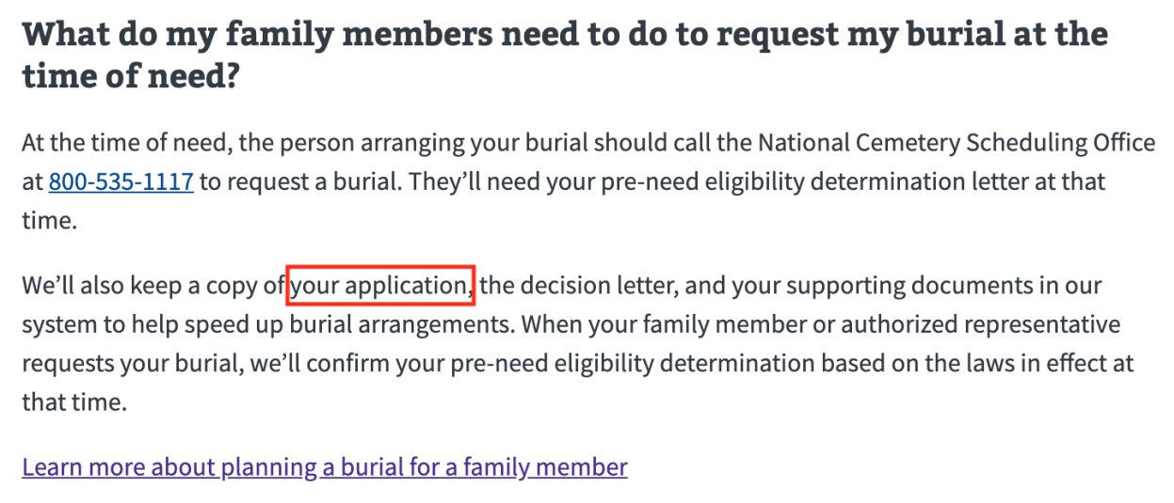

NOTE: New copy for 2nd paragraph above:

We’ll also keep a copy of your pre-need application, the decision letter, and your supporting documents in our system to help speed up burial arrangements. When your family member or authorized representative requests your burial, we’ll confirm your pre-need eligibility determination based on the laws in effect at that time.

**Second Screen Shot Source content:**

<https://www.cem.va.gov/CEM/pre-need/FAQ/#9>

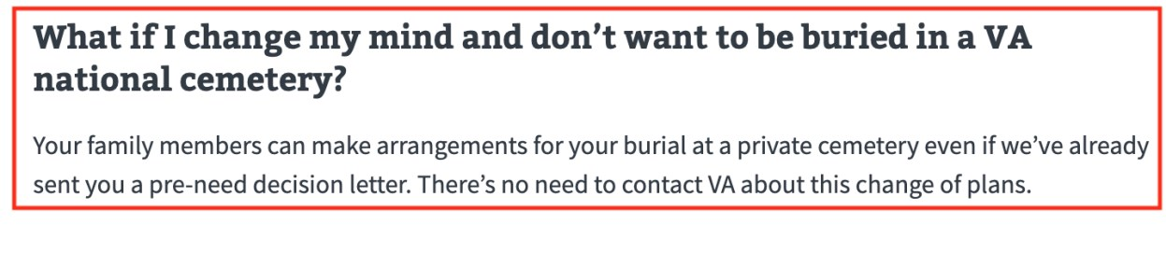

New copy [same headline]:

Your family members can make arrangements for your burial at a private cemetery even if we’ve already sent you a pre-need decision letter. There’s no need to contact VA about this change of plans.

However, even if you are buried at a private cemetery, your family members can still request a headstone or marker at the time of need. The family member can make this request using [VA Form 40-1330](http://www.va.gov/vaforms/va/pdf/VA40-1330.pdf). To make this request, print out the form and fill it out, and mail the completed form to:

Memorial Products Service (41B)

Department of Veterans Affairs

5109 Russell Road

Quantico, VA 22134-3903

**Third Screen Shot Source content:**

<https://www.cem.va.gov/CEM/pre-need/FAQ/#14>

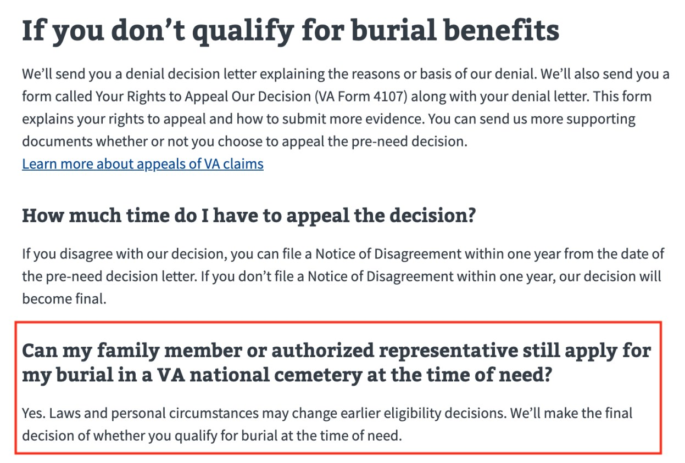

NEW COPY, UNDER H2: If you don’t qualify for burial benefits:

We’ll send you a denial decision letter explaining the reasons or basis of our denial. We’ll also send you a form called Your Rights to Seek Further Review of Our Decision ([VA Form 20-0998](https://www.vba.va.gov/pubs/forms/VBA-20-0998-ARE.pdf)) along with your denial letter. This form explains your rights to appeal and how to submit more evidence. You can send us more supporting documents whether or not you choose to appeal the pre-need decision.

[Learn more about appeals of VA claims](https://www.va.gov/opa/publications/benefits_book/benefits_chap14.asp).

**H3: How much time do I have to appeal the decision?**

You have one year from the date of our decision to file your appeal.

[Learn how to file your claim using VA Form 20-0998](https://www.va.gov/vaforms/form_detail.asp?FormNo=20-0998).

[red box fixes are ok as is]

# How to apply for a Veterans burial allowance

**Preview page url (staging environment):**

This will be the new VA.gov page with the final content:

<https://vagov-content-pr-137.herokuapp.com/burials-memorials/veterans-burial-allowance/>

*See the screen shots on the next 4 pages. Red boxes are drawn around proposed new content.*

**First Screen Shot Source content:**

<https://www.benefits.va.gov/BENEFITS/factsheets/burials/Burial.pdf><https://www.benefits.va.gov/COMPENSATION/claims-special-burial.asp>

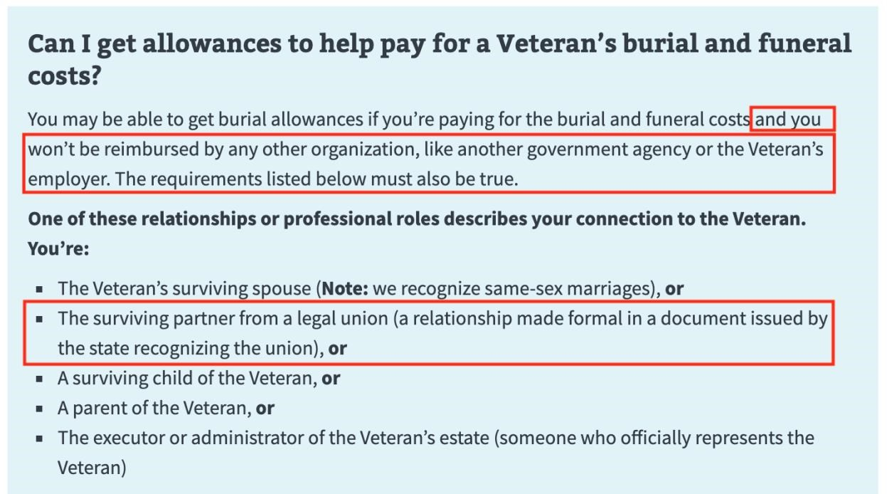

**Second Screen Shot Source content:**

<https://www.benefits.va.gov/BENEFITS/factsheets/burials/Burial.pdf>

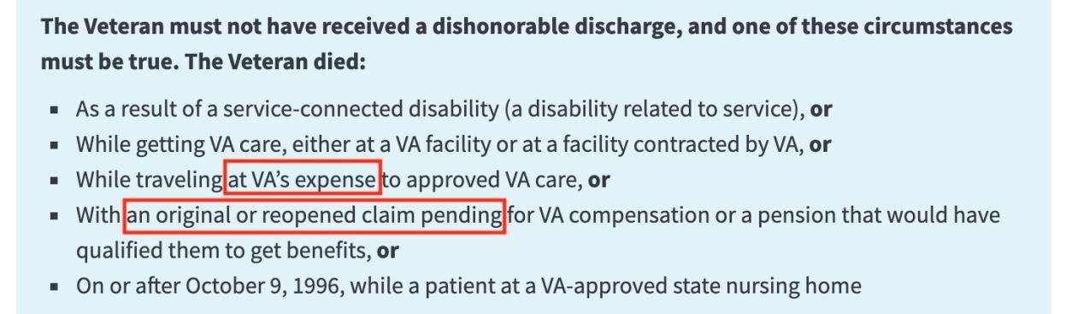

[[Revised copy for above section]]:

The Veterans must not have received a dishonorable discharge, and one of these circumstances must be true. The Veteran died:

* As a result of a service-connected disability (a disability related to service), or
* While getting VA care, either at a VA facility or at a facility contracted by VA, or
* While traveling with proper authorization, and at VA expense, either to or from a facility for an examination, or to receive treatment or care, or
* With an original or reopened claim for VA compensation or pension pending at the time of death, if they would have been entitled to benefits before the time of death

While receiving VA pension or compensation

While eligible for VA pension or compensation at time of death, but instead received full military retirement or disability pay

[[additional]]

**Third Screen Shot Source content:**

<https://www.benefits.va.gov/COMPENSATION/claims-special-burial.asp>

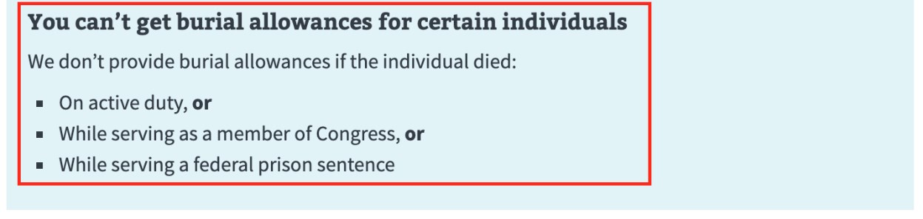

**Fourth Screen Shot Source content:**

<https://www.benefits.va.gov/BENEFITS/factsheets/burials/Burial.pdf>

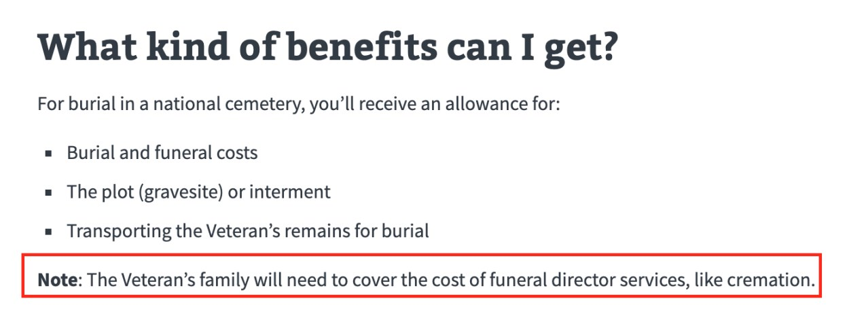

**Fifth Screen Shot Source content:**

<https://www.benefits.va.gov/BENEFITS/factsheets/burials/Burial.pdf>

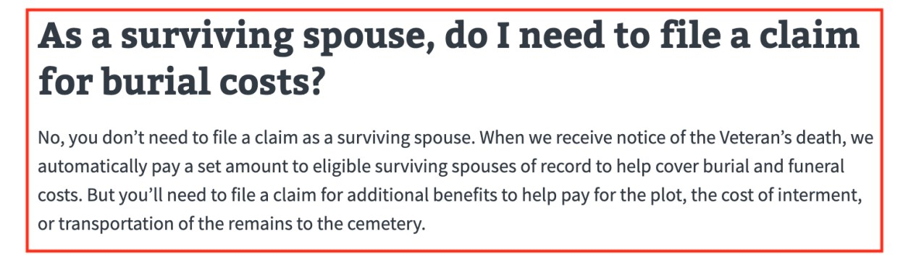

REVISE:

No, you don’t need to file a claim as a surviving spouse, as long as you are listed as the Veteran’s spouse on the Veteran’s profile. When we receive notice of the Veteran’s death, we automatically pay a set amount to those eligible surviving spouses to help pay for the plot, the cost of internment, or transportation of the remains to the cemetery.

**Sixth Screen Shot** **Source content:**

<https://www.benefits.va.gov/BENEFITS/factsheets/burials/Burial.pdf><https://www.benefits.va.gov/COMPENSATION/claims-special-burial.asp>

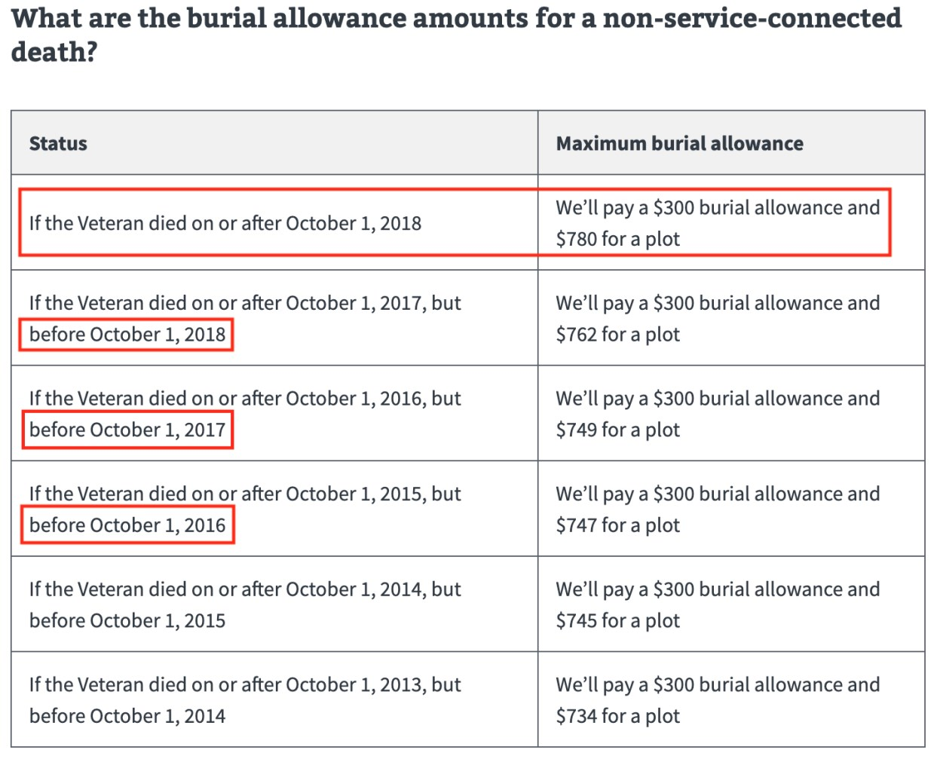

REVISE: Remove the word Maximum from right-hand column; column header should be: **Burial allowance**

**Seventh Screen Shot** **Source content:**

<https://www.benefits.va.gov/BENEFITS/factsheets/burials/Burial.pdf><https://www.benefits.va.gov/COMPENSATION/claims-special-burial.asp>

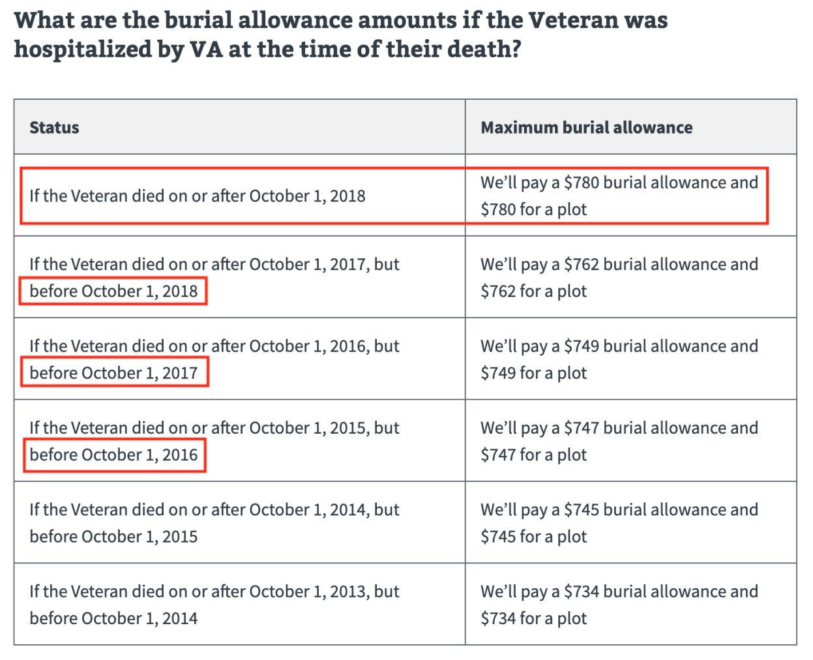

REVISE: New Header:

**What are the burial allowance amounts for a non-service-connected death if the Veteran was hospitalized by VA at the time of their death?**

Also:

Remove Maximum from right hand column:

**Burial allowance**